Chih Hsuan Huang

ID:934554197

huanchih@oregonstate.edu

CS 575

Project 0 - Simple OpenMP Experiment

1. Tell what machine you ran this on

CPU: Intel(R) Xeon(R) CPU E5-2630 v3 @ 2.40GHz

Memory: 64GB

Machine: rabbit.engr.oregonstate.edu

Array size: 16384

1. What performance results did you get?

|  |  |  |
| --- | --- | --- |
| Number of Threads | Peak Performance | Average Performance |
| Using 1 thread | 149.53 MegaMults/Sec | 144.85 MegaMults/Sec |
| Using 4 threads | 532.98 MegaMults/Sec | 483.88 MegaMults/Sec |

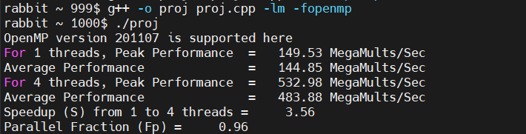

1. What was your 4-thread-to-one-thread speedup?

Speedup, S = (Performance with four threads) / (Performance with one thread) Speedup, S = P4 / P1 = 532.98 / 149.53 = 3.56

1. Why do you think it is behaving this way?

In the experiment, when increasing the number of threads from 1 to 4, the observed performance improvement was approximately 3.56 times, which is less than the ideal 4 times. This is mainly because when the number of added threads exceeds the number of cores in the processor, the performance improvement is no longer linear because the cores must switch between multiple threads, adding additional overhead. Furthermore, according to Amdahl's law, the maximum speedup of a program is limited by the portion of it that can be parallelized. Even if some programs can be perfectly parallelized, some still need to be executed serially, which limits the overall performance improvement.

1. What was your Parallel Fraction, Fp?

float Fp = (4./3.)*( 1. - (1./S) );

Fp = (4./3.)*( 1. - (1./3.56) ); Fp = 0.96

1. Commentary?

The results reflects that in multi-threaded parallel processing, in addition to the physical limitations of the hardware, the parallelizability of the software itself is also a key factor in improving performance. Therefore, even if the hardware resources are sufficient, we still need to carry out detailed parallel optimization of the program in order to achieve higher performance improvement.